CRAB DUMPLINS
Submitted by: Creative Cajun Cooking, Jimmy Babin

Ingredients:
1 pack of Creative Cajun Cooking’s Dumplin’ Magic Seasoning
5 cups water
4-5 cups heavy cream or half and half (1 quart will do, add extra if you want)
1¼ cup all-purpose flour
1 can of biscuits (about 1 pound)
1 pound crab meat, picked for shell pieces
Optional: Frozen/canned green peas and sliced carrots, sliced green onions for garnish

Instructions:
(Stovetop) In a 6 quart or larger pot, mix water, and Creative Cajun Cooking’s Dumplin’ Magic seasoning. Bring to a boil over medium high heat.
While that’s heating up, break out a large cutting board and spread out flour, then pile most of it in the corner, leaving a thin coating on the cutting board. Open the can of biscuits and one at a time roll each one out to about ⅛ inch thickness using a light sprinkle of flour to keep them from sticking. Cut the flat biscuits into 6-8 pieces pending size of dumplings you want. Pile the cut biscuits in one corner of cutting board for placing in a pot at a later time.
Scrape up the extra flour and place in a bowl, then pour the cream into it and whisk until smooth. Pour in the cream and flour mixture making sure it is stirred frequently by scraping the bottom so it doesn’t stick. Once the liquid thickens up, and it has a slow bubbling, add in the biscuit pieces a few at a time, stirring softly until they swell up.
Once the dumplings are cooked and no longer doughy, gently add in the crab meat. Then add in, if you would like, a few green peas and or carrots (frozen or canned). Stir and cook just until heated through. Once the Crab and Dumplings are placed in a bowl, you can sprinkle some finely chopped green onion tops for added color.
Website:
www.creativecajuncooking.com
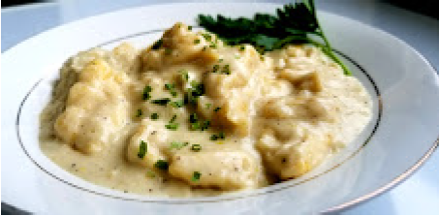
Photo credits: @TheOutdoorKitchenShow, Marissa Turner

